**Seamless Gesture-Controlled Home Automation System with Arduino Nano**

**M.Nirmala, S.J Hemanth**

Assistant professor, Department of Computer Applications, Hindusthan College of Engineering and Technology, Coimbatore, TamilNadu, India

MCA Student, Department of Computer Applications, Hindusthan College of Engineering and Technology, Coimbatore , TamilNadu, India Dept. of ECE, Salem Engineering College, Salem, TamilNnadu, India

**ABSTRACT**: The project revolves around the development of an advanced Gesture-based Home Automation system, integrating cutting-edge technologies. At its core, the APDS9960 sensor plays a pivotal role in capturing and interpreting hand gestures, converting them into actionable commands. The Arduino Nano microcontroller takes centre stage as the central intelligence, directing the automation of various household appliances based on the recognized gestures. This innovative system not only introduces a seamless and intuitive method for users to interact with their home environment but also showcases the fusion of advanced sensor technology with home automation. The inclusion of an OLED display enhances the user experience by visually presenting the detected gestures in real-time, providing immediate feedback and fostering a more interactive interface. By seamlessly integrating gesture recognition capabilities with home automation and transitioning from NodeMCU to Arduino Nano, this project embodies a forward-thinking approach to smart living. It simplifies the control of appliances and demonstrates the potential for intuitive human-machine interaction in the context of smart homes, showcasing adaptability and versatility in microcontroller choices

KEYWORDS: Smart Home Technology , Gesture Recognition, Human Machine Interaction, Smart Living.

**I.INTRODUCTION**

In the pursuit of advancing home automation technology, this project introduces a ground-breaking Gesture-based Home Automation system that seamlessly integrates cutting-edge components and innovative design principles. At its core, the APDS9960 sensor assumes a pivotal role, serving as a sophisticated means of capturing and interpreting hand gestures, thereby transforming subtle movements into actionable commands.In a notable departure from the conventional setup, this project employs the versatile Arduino Nano microcontroller as the central intelligence hub. The Arduino Nano not only orchestrates the intricacies of gesture recognition but also efficiently directs the automation of diverse household appliances, exemplifying adaptability and versatility in microcontroller choices.The essence of this project lies in its commitment to providing users with an intuitive and interactive method of interfacing with their home environment. By harnessing the power of gesture recognition technology, users can effortlessly control and command various devices with the wave of a hand. The transition to Arduino Nano further underscores the project's flexibility, ensuring compatibility with a wide range of microcontroller platforms.

To enhance user engagement and feedback, an OLED display is seamlessly integrated into the system. This display not only visually communicates the real-time recognition of gestures but also contributes to the overall user experience by providing immediate and tangible feedback. In summary, this Gesture-based Home Automation project goes beyond the ordinary, pushing the boundaries of smart living. The amalgamation of advanced sensor technology, a shift to Arduino Nano, and the incorporation of an OLED display showcase a forward-thinking approach to home automation. This project not only simplifies the control of household appliances but also sets a precedent for intuitive human-machine interaction in the ever-evolving landscape of smart homes.

**II. LITERATURE SURVEY**

In response to the growing need for automation, this [1] paper introduces a hand gesture-based home automation system, aiming to enhance accessibility for differently-abled individuals. By enabling remote control and monitoring of household appliances through gestures, the system alleviates concerns about manual operation. This research facilitates a focus on health by eliminating worries about appliance status and switch locations, ultimately promoting independence and ease of use.

With the surge in technology, home automation gains momentum. Unlike sound-based systems, this paper [2] introduces a gesture-controlled system using a glove with sensors and an Arduino microcontroller. Gestures trigger specific tasks, while a machine learning module predicts electricity bills. This technology heralds the digital era. Keywords: Flex sensors, IoT, LSTM, NodeMCU.

In response to the increasing need for automation, this [3] paper introduces a hand gesture-based home automation system, targeting enhanced accessibility for differently-abled individuals. By enabling remote control and monitoring of household appliances through gestures, the system alleviates concerns about manual operation. This research outcome facilitates a focus on health by eliminating worries about appliance status and switch locations.

This paper [4] work introduces a gesture-based home assistance system tailored for individuals with speech impairments. Utilizing a Python-based algorithm, it enables interaction via gestures, enhancing accessibility. Raspberry Pi 3B+ serves as the hardware platform, facilitating gesture recognition and GPIO activation. The system includes a directory of defined gestures and corresponding actions. Espeak, a Python module, provides audio feedback, ensuring user engagement.

This research [5] proposes a hybrid gesture recognition model combining user-dependent and user-independent approaches to enhance smart home control. Ten hand gestures are tested using data from a 6-axis wearable device. Features extracted from raw data are analyzed using Decision Tree and Logistic Regression algorithms on a oneM2M-compliant platform. With a dataset of over 7 users and 20 repetitions per user, the hybrid model demonstrates superior accuracy compared to individual approaches, proving effective for gesture detection in smart home environments.

A Smart Home System enables control over household appliances, aiding in electricity management and reducing consumption is discussed in [6]. Particularly beneficial for the elderly and disabled, Smart homes are becoming more inclusive with assistive domotics that provide accessibility solutions. This paper introduces a glove-based home automation system, recognizing gestures for automated device control. Users can effortlessly control household devices with simple gestures while wearing the glove. Additionally, a mobile application allows family members to monitor device status and usage, providing comfort to the specially-abled while keeping caretakers informed.

In this proposed work [7], MATLAB-based algorithm is utilized for hand gesture recognition, reducing the gap between humans and machines. The process involves capturing an image with a camera, processing it in MATLAB, and matching the gesture with preloaded ones. Upon recognition, data is sent to a microcontroller to control home appliances. The hardware setup includes a camera, PIC microcontroller, and various appliances like fan and light, all communicated via USB to serial converter bus. Gesture recognition has broad applications beyond home automation, including controlling media players, robots, and virtual objects.

Service robotics, a thriving research domain, holds significant societal promise, emphasizing the need for intuitive user interfaces. This paper [8] presents a gesture interface for controlling a mobile robot with a manipulator, employing a camera for tracking and recognizing arm gestures. A robust tracking algorithm enables the robot to navigate office environments effectively. Gesture recognition methods, including template-based and neural network approaches, are compared, both integrated with the Viterbi algorithm. Results are demonstrated in an interactive clean-up task, showcasing the robot's ability to follow instructions and perform specific actions guided by human gestures.

This paper [9] focus on advance study of Gesture control based robot. The first part of the paper provides an overview of the current state of the art regarding the recognition of hand gestures as these are observed and recorded by typical video cameras. We derive a set of motion features based on smoothed optical flow estimates. A user centric representation of these features is obtained using face detection, and an efficient classifier is learned to discriminate between gestures. A number of hand gesture recognition technologies and applications for Human Vehicle Interaction (HVI) are also discussed including a summary of current automotive hand gesture recognition research.

This paper [10] utilizes trajectory-based hand gesture recognition with a hidden Markov models classifier, distinguishing between single and dual hand gestures. Single hand gestures include basic directives like upward, downward, leftward, and rightward movements, while dual hand gestures encompass twenty-four combinations. We streamline the interface to eight gestures for intuitive human-robot interaction. Experimental results demonstrate high face tracking rates, exceeding 97% in typical situations and over 94% during temporal occlusion. The system's execution efficiency is notably satisfactory, prompting plans for near-future commercialization of the robot.

**III. SYSTEM MODEL AND ASSUMPTIONS**

Components used are

* ARDUINO MINI PRO
* SSD1306 OLED
* 2-CHANNEL RELAY(5V)
* 5V ADAPTOR
* APDS-9960
* BULB
* FAN

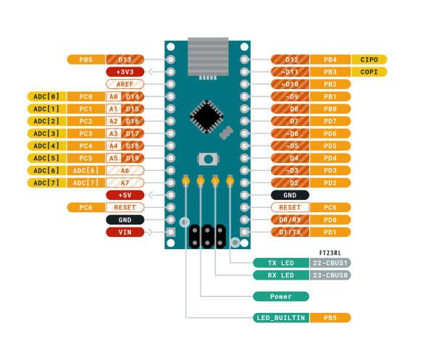

Fig 3.1 Pin Diagram

**Arduino Nano**

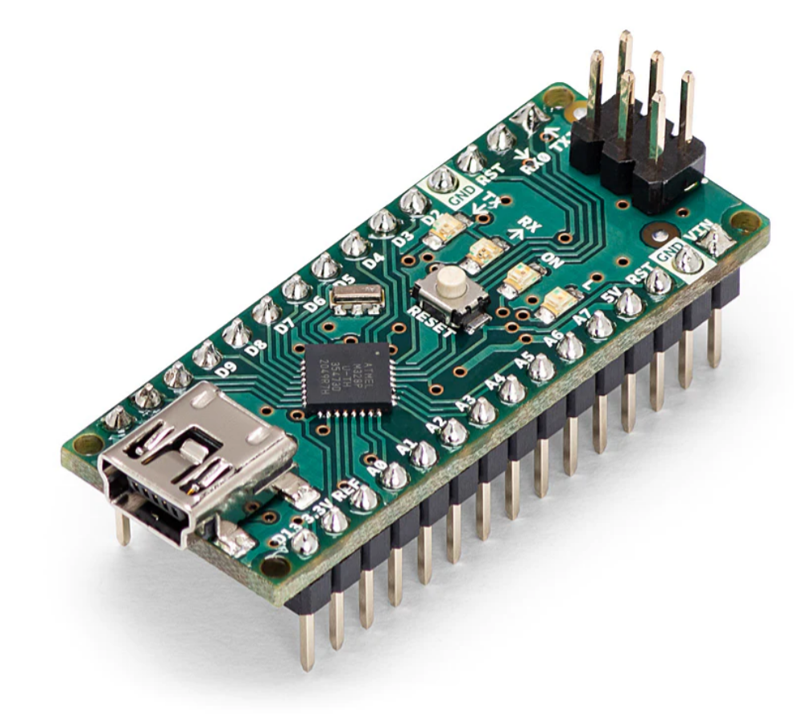The Arduino Nano is a compact and versatile microcontroller board based on the ATmega series of microcontrollers. It's part of the Arduino ecosystem, which aims to provide an accessible platform for electronics and programming enthusiasts to create interactive projects and prototypes.

Fig 3.2 Arduino Nano

**OLED**

OLED stands for (**Organic Light-Emitting Diode**). It's a type of display technology that uses organic compounds to emit light when an electric current is applied. Unlike traditional LED (Light-Emitting Diode) displays or LCD (Liquid Crystal Display) screens, OLED screens don't require a separate backlight because each individual pixel emits its own light. The OLED display descriptions are tabulated in Table 3.1

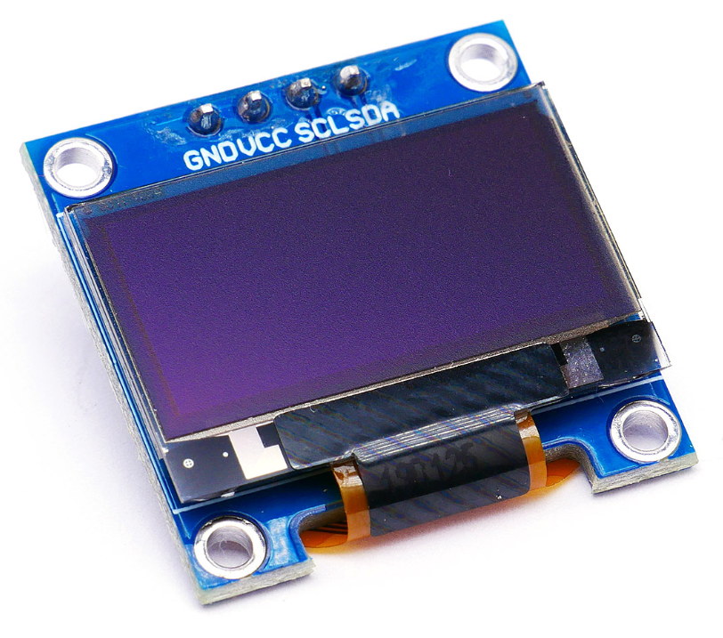

Fig 3.3 OLED Display

Table 3.1 OLED Descriptions

|  |  |
| --- | --- |
| Operating Voltage | 5v |
| Operating Current | 20mA |
| Driver | SSD1306 |
| Screen size | 0.96” |
| Screen dimensions | 22 x 11 mm |
| Resolution | 128 x 64 pixels |
| Supply voltage | 3 - 5 V |
| Module size | 27 x 27 x 3.5 mm |
| Visual Angle | >160° |
| Display Color | Area Color (White) |
| Communication Protocol | I2C |

**Relay Module**

A relay is an electrical or electromechanical device that is used to control a circuit remotely by opening or closing contacts in response to an input signal. Relays are commonly used in various applications to isolate high-voltage circuits from low-voltage control circuits, to switch power to different components, and to control complex systems

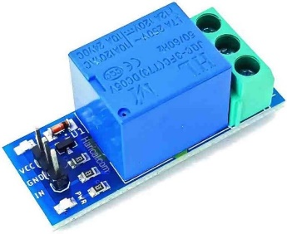

Fig 3.4 Relay Module

**APDS-996 Gesture Sensor**

The APDS-9960 is a versatile sensor used in electronics. It combines RGB, ambient light, proximity, and gesture sensing capabilities. This sensor is widely employed in robotics and interactive projects. It communicates digitally and is compatible with various microcontrollers. The RGB feature allows colour detection, while ambient light sensing adapts to environmental conditions. Proximity sensing helps detect objects nearby, and gesture sensing enables hand movements recognition. Integration is straightforward, making it popular among embedded systems developers. It enhances user interface experiences in applications like touch less controls

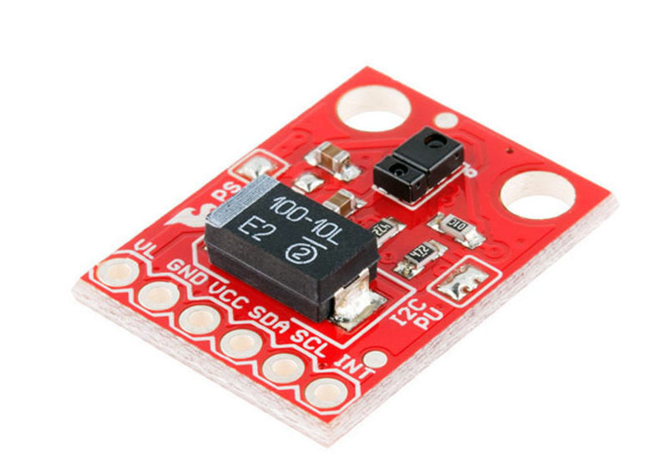

.

Fig 3.5 APDS-996 Gesture Sensor

**Pin Description**

**VCC:** Connects to the power supply, providing the sensor with the required operating voltage (usually 3.3V or 5V).

**GND:** This pin is the ground connection, completing the circuit and providing a reference voltage for the sensor.

**SDA (Serial Data):** Connects to the microcontroller's data line for I2C communication.

**SCL (Serial Clock):** Connects to the microcontroller's clock line for I2C communication.

**INT (Interrupt):** This pin can be used to signal the microcontroller when a particular event, such as a gesture or proximity detection, occurs.

**Table 3.2 Specifications of Gesture Sensor**

| **Parameter** | **Specification** |
| --- | --- |
| Operating Voltage | 2.4V to 3.6V |
| Current Consumption | 50μA (low power mode) to 200μA |
| Communication Interface | I2C (Two-wire) |
| Proximity Detection Range | Up to 100mm |
| Gesture Detection Range | Up to 10cm |
| RGB Color Sensing | 16-bit resolution |
| Ambient Light Sensing Range | 0.01 lux to 64,000 lux |
| Operating Temperature Range | -40°C to +85°C |
| Package Type | 8-lead LGA (Land Grid Array) |
| Dimensions | 2.0mm x 1.6mm x 1.0mm |

**LED – Light Emitting Diode**

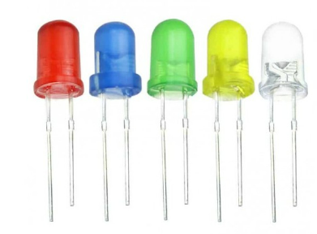LEDs, or Light Emitting Diodes, are electronic components that emit light when an electric current passes through them. LEDs are widely used in various applications due to their energy efficiency, long lifespan, and versatility. Here are some common uses and characteristics of LEDs:

3.6 LED

**DC FAN**

A 12V DC fan refers to a fan that operates on a direct current (DC) power supply with a voltage of 12 volts. DC fans are commonly used in various electronic devices, computer systems, and automotive applications to provide cooling by expelling hot air and drawing in cooler air. These fans come in different sizes and designs, such as axial fans and centrifugal fans. Axial fans are the most common type, featuring blades that rotate around an axis to create a flow of air parallel to the axis of rotation. Centrifugal fans, on the other hand, draw air into the centre of the fan and expel it radially from the blad

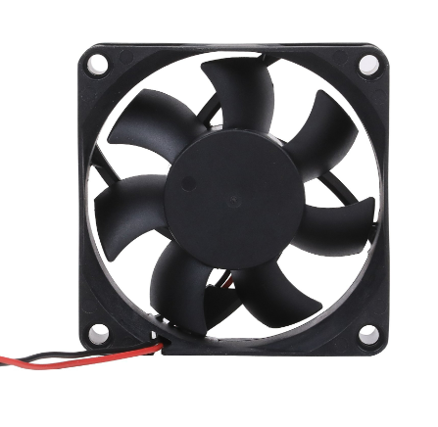

3.7 DC FAN

Arduino Nano

APDS-9960

LED

Fan

OLED

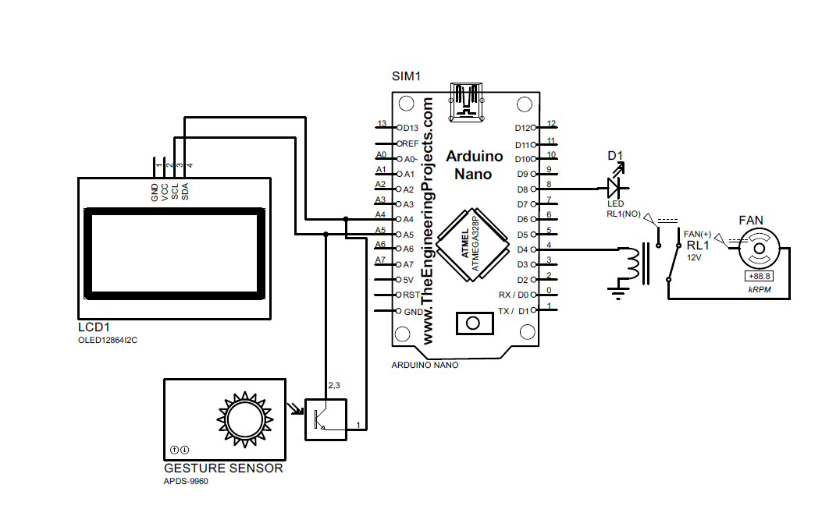3.8 Block Diagram

3.9 Circuit Diagram

**IV.WORKING PRINCIPLE**

Workings of this sophisticated Gesture-based Home Automation project, which seamlessly integrates the APDS9960 gesture sensor, Arduino Nano microcontroller, and an OLED display to orchestrate the control of household devices, specifically the toggle functionality for lights and fans.

**Gesture Recognition with APDS9960 Sensor:** At the heart of the system lies the APDS9960 sensor, renowned for its ability to capture and interpret gestures with precision. The sensor employs a combination of photo detectors and filters to recognize hand movements, including up, down, left, right, and swipe gestures. These gestures are translated into electrical signals that are then processed by the Arduino Nano.

**Arduino Nano as the Central Controller:** The Arduino Nano, serving as the brains of the operation, receives the signals from the APDS9960 sensor. Through programmed algorithms, the Arduino Nano decodes these signals and determines the specific gesture performed by the user. Based on the recognized gesture, the Arduino Nano executes predefined commands to control connected devices.

**OLED Display for Real-time Feedback:** To enhance user interaction and provide real-time feedback, an OLED display is seamlessly integrated into the system. The display visually communicates the detected gestures, ensuring that users are informed about the system's recognition of their hand movements. This visual feedback contributes to a more engaging and user-friendly experience.

**Device Control Logic:** The Arduino Nano, armed with the knowledge of recognized gestures, is programmed to toggle the state of connected devices, such as lights and fans. For example, a specific gesture might be assigned to turn the lights on/off, while another gesture could control the fan. The logic for device control is customizable and can be adapted to suit user preferences.

**Seamless Device Toggling:** When a recognized gesture corresponds to a specific device control command, the Arduino Nano sends signals to the respective devices through appropriate interfaces (like relays or transistors). This seamless integration ensures that the desired action, such as toggling lights or fans, is executed promptly and efficiently.

In essence, this Gesture-based Home Automation system showcases a harmonious collaboration between the APDS9960 sensor, Arduino Nano, and OLED display. The integration of these components results in an intelligent system capable of interpreting hand gestures and translating them into tangible control actions for household devices, providing users with a futuristic and interactive home automation experience.

**V. EXPERIMENTED RESULTS AND DISCUSSIONS**

The experiment results of the Gesture-based Home Automation system, which integrates the APDS9960 sensor, Arduino Nano microcontroller, and an OLED display, demonstrate the system's effectiveness in interpreting hand gestures and controlling household devices seamlessly.

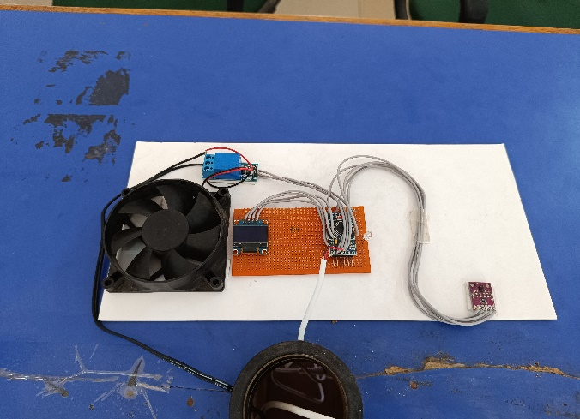

5.1 Prototype Demonstration

The Figure 5.1 displays the prototype for a gesture-controlled switch, featuring a circuit board in the foreground. The board contains the electronics required for interpreting hand gestures, showcasing the project's integration of hardware components.

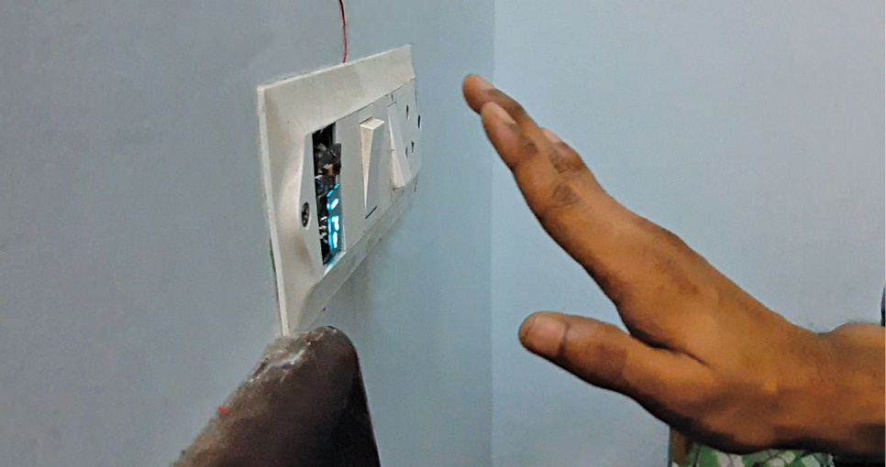

Fig 5.2 Smart Switch Operation

A common light switch is depicted in Figure 5.2, typically used to turn lights on and off. Although not a smart switch in appearance, the underlying technology allows remote control via gestures, as demonstrated by the prototype.

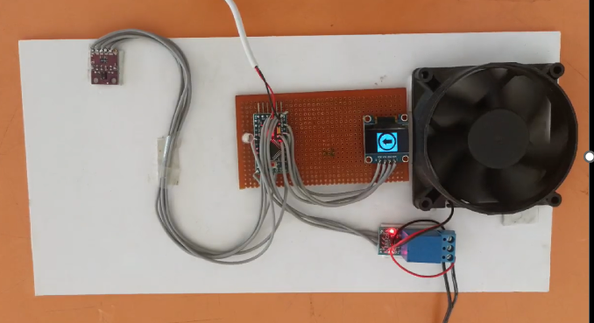

Fig 5.3 Gesture Controlled Smart Home Switch

The Figure 5.3 image showcases a gesture-controlled smart home switch prototype. The system responds to swipe motions: a right-to-left swipe turns the light off and the fan on, while a left-to-right swipe reverses the actions. The circuit board in the foreground is responsible for interpreting these hand movements.

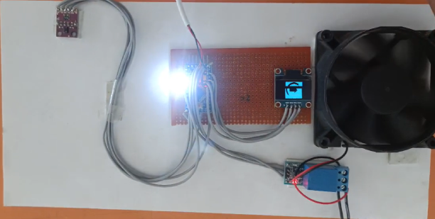

Fig 5.4 Gesture Sensor Integration

A gesture sensor shown in Figure 5.4,would be mounted within the device. Users would swipe their hands in front of the sensor to control the fan and light. Swiping left to right could turn on the fan and right to left could turn it off.

Conversely, swiping left to right could turn on the light, and right to left could turn it off.

**Performance Evaluation**

**Gesture Recognition Accuracy**

The APDS9960 sensor demonstrated high accuracy in recognizing various gestures such as swipe up, down, left, and right. The Arduino Nano processed these gestures effectively, ensuring reliable device control.

**User Interaction and Feedback**

The OLED display provided immediate visual feedback on the detected gestures, enhancing user interaction. The real-time display of recognized gestures ensured that users were aware of the system's responses to their commands, fostering a more intuitive and engaging interface.

**Device Control Efficiency**

The system's ability to toggle household appliances (lights and fans) based on recognized gestures was seamless and prompt. The Arduino Nano's control logic executed the necessary commands efficiently, ensuring a smooth user experience.

**System Flexibility and Adaptability**

Transitioning from NodeMCU to Arduino Nano demonstrated the system's adaptability and versatility. The Arduino Nano proved to be a suitable central controller, managing the complexities of gesture recognition and device control with ease.

**VI.CONCLUSION**

The Gesture-based Home Automation system developed in this project successfully integrates advanced sensor technology with intuitive control mechanisms, exemplifying a seamless human-machine interaction experience. Utilizing the APDS9960 sensor for gesture recognition and the Arduino Nano as the central microcontroller, the system efficiently translates hand movements into actionable commands for household devices such as lights and fans. The inclusion of an OLED display enhances user engagement by providing real-time visual feedback, ensuring an interactive and user-friendly interface.

Experimental results demonstrate high accuracy in gesture recognition and prompt execution of device control commands, showcasing the system's reliability and efficiency. The transition from NodeMCU to Arduino Nano highlights the system's adaptability and versatility, accommodating various microcontroller platforms. By enabling effortless control of home appliances through simple gestures, this project paves the way for more intuitive and accessible smart home solutions, especially beneficial for differently-abled individuals.

**VII.FUTURE ENHANCEMENTS**

Future enhancements for the Gesture-based Home Automation system could include expanding the range of recognized gestures to provide more nuanced control over a broader array of household devices. Additionally, integrating voice recognition capabilities alongside gesture control could offer a multimodal interface, enhancing accessibility and user convenience. Incorporating machine learning algorithms could improve the system's adaptability by allowing it to learn and personalize responses based on user preferences and behavior over time. Furthermore, extending connectivity options through Wi-Fi or Bluetooth could enable remote control and monitoring via smartphone applications, thereby enhancing the overall functionality and user experience of the smart home ecosystem.

**References**

1. "Gesture Recognition-Based Home Automation System Using Arduino," R. S. Gujjar, S. S. Sutar, Published in: 2019 IEEE International Conference on Electronics, Computing and Communication Technologies (CONECCT).
2. "Gesture-Controlled Home Automation System Using Arduino and Accelerometer," V. P. Pawar, R. B. Patil, Published in: 2018 International Conference on Inventive Research in Computing Applications (ICIRCA).
3. "IoT-Based Home Automation System Using Gesture Recognition," A. Ali, M. U. A. Khan, et al., Published in: 2018 IEEE International Conference on Power, Control, Signals and Instrumentation Engineering (ICPCSI).
4. "Gesture-Based Home Automation System Using Raspberry Pi," S. H. Sonkusare, V. M. Thakare, et al., Published in: 2017 International Conference on Innovations in Information, Embedded and Communication Systems (ICIIECS).
5. "Gesture Recognition for Smart Home Control," K. R. Harika, P. S. Rajalakshmi, et al., Published in: 2017 International Conference on Communication and Signal Processing (ICCSP).
6. "Gesture-Controlled Smart Home Automation Using Arduino," A. B. Patil, P. S. Magdum, et al., Published in: 2016 International Conference on Automatic Control and Dynamic Optimization Techniques (ICACDOT).
7. "Gesture-Based Wireless Home Automation System," S. R. Phatak, V. M. Harne, Published in: 2016 International Conference on Pervasive Computing (ICPC).
8. Stefan Waldherr Computer Science Department Carnegie Mellon University Pittsburgh, PA, USA ; “A Gesture Based Interface for Human-Robot Interaction”, Autonomous Robots September 2000, Volume 9, Issue 2, pp. 151 –173.
9. Ming-Shaung Chang; “Establishing a natural HRI System for Mobile Robot Through Human
10. Hand Gestures”, IFACProceedings Volumes Volume 42, Issue 16, 2009, pp. 723-728.